Background on Galatian People

Galatia – Wikipedia and Encyclopedia Britannica as sources

Where was Galatia?
Galatia was bounded on the north by Bithynia and Paphlagonia, on the east by Pontus and Cappadocia, on the south by Cilicia and Lycaonia, and on the west by Phrygia. Its capital was Ancyra (i.e. Ankara, today the capital of modern Turkey).

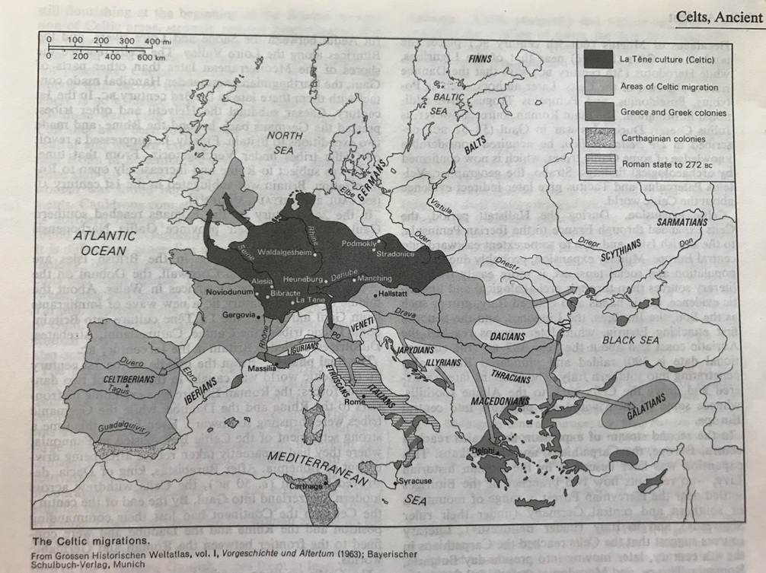

Who were the Galatian people?
The Galatians were a Gallic people of the Hellenistic period that dwelt mainly in the north central regions of Asia Minor or Anatolia, in what was known as Galatia, in today's Turkey. The Gauls of Gallia Celtica according to the testimony of Caesar called themselves Celtae in their own language (as distinct from Belgae and Aquitani), and Galli in Latin.

What was their social organization?
Gaul was never united under a single ruler or government, but the Gallic tribes were capable of uniting their forces in large-scale military operations. They reached the peak of their power in the early 3rd century BC. The Roman Republic put pressure on the Gallic sphere of influence; the Battle of Telamon of 225 BC heralded a gradual decline of Gallic power over the 2nd century, until the eventual conquest of Gaul in the Gallic Wars of the 50s BC. After this, Gaul became a province of the Roman Empire.

Gaulish society was dominated by the druid priestly class. The fundamental unit of Gallic politics was the tribe, which itself consisted of one or more of what Caesar called "pagi." The tribes were organised into larger super-tribal groups that the Romans called civitates. These administrative groupings would be taken over by the Romans in their system of local control, and these civitates would also be the basis of France's eventual division into ecclesiastical bishoprics and dioceses, which would remain in place — with slight changes — until the French Revolution.

Although the tribes were moderately stable political entities, Gaul as a whole tended to be politically divided, there being virtually no unity among the various tribes. Only during particularly trying times, such as the invasion of Caesar, could the Gauls unite under a single leader. Even then, however, the faction lines were clear.

Where did they come from?
The Gauls were a group of Celtic peoples of West-Central Europe in the Iron Age and the Roman period (roughly from the 5th century BC to the 5th century AD). The area they inhabited was known as Gaul.

The Romans knew the Celts then living in what became present-day France as Gauls. The territory of these peoples probably included the Low Countries, the Alps and present-day northern Italy. Julius Caesar in his Gallic Wars described the 1st-century BC descendants of those Gauls.

The Gauls emerged around the 5th century BC as the La Tène culture north of the Alps (spread across the lands between the Seine, Middle Rhine and upper Elbe). By the 4th century BC, they spread over much of what is now France, Belgium, Spain, Portugal, Switzerland, Southern Germany, Austria, the Czech Republic and Slovakia by virtue of controlling the trade routes along the river systems of the Rhône, Seine, Rhine, and Danube, and they quickly expanded into Northern Italy, the Balkans, Transylvania and Galatia.

Mary’s summary of deeper history
When people migrated out of Africa, they settled in small numbers in present-day Europe, so there was at first no dominant culture in Europe. Some people, however, moved to the area currently around western Ukraine and stayed there long enough to develop their own new cultural and linguistic group, the Indo-Europeans. Some time after this group had developed a recognizable identity, they began to migrate in different directions.

One of these migrating groups moved into Europe by traveling up the rivers and establishing settlements along those rivers. These were the people who would become the Celtic culture.
They excelled at making carts and river boats. They raised crops and animals and were proficient traders.

They lived at times in hill forts, but much of the time they lived in large walled enclosures. Caesar named this large inclosure an oppidum. These were the first towns in Europe.

Wikipedia’s description of Oppidum

The word is derived from the earlier Latin ob-pedum, "enclosed space", possibly from the Proto-Indo-European *pedóm-, "occupied space" or "footprint". They were important economic sites, places where goods were produced, stored and traded, and sometimes Roman merchants had settled and the Roman legions could obtain supplies. They were also political centres, the seat of authorities who made decisions that affected large numbers of people.

Caesar named 28 oppida. By 2011, 21 of these had been positively identified by historians and archaeologists: either there was a traceable similarity between the Latin and the modern name of the locality (e.g. Orléans-Cenabum), or excavations had provided the necessary evidence (e.g. Alesia). Most of the places that Caesar called oppida were city-sized fortified settlements. However, Geneva, for example, was referred to as an oppidum, but no fortifications dating to this period have yet been discovered there. However, the oppidum of Brenodurum at Bern, which was confirmed by an archaeological discovery.
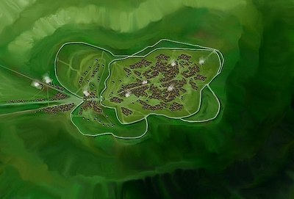
Bibracte France, seen from above, 1st century BC

The main features of the oppida are the walls and gates, the spacious layout, and usually a commanding view of the surrounding area. The major difference with earlier structures was their much larger size. Earlier hill forts were mostly just a few hectares in area, whilst oppida could encompass several dozen or even hundreds of hectares. They also played a role in displaying the power and wealth of the local inhabitants and as a line of demarcation between the town and the countryside. According to Jane McIntosh, the "impressive ramparts with elaborate gateways ... were probably as much for show and for controlling the movement of people and goods as for defense."

The development of oppida was a milestone in the urbanisation of the continent as they were the first large settlements north of the Alps that could genuinely be described as towns. Caesar pointed out that each tribe of Gaul would have several oppida but that they were not all of equal importance, perhaps implying some form of settlement hierarchy.

Oppida continued in use until the Romans began conquering Iron Age Europe. Even in the lands north of the River Danube that remained unconquered by the Romans, oppida were abandoned by the late 1st century AD. In conquered lands, the Romans used the infrastructure of the oppida to administer the empire, and many became full Roman towns.
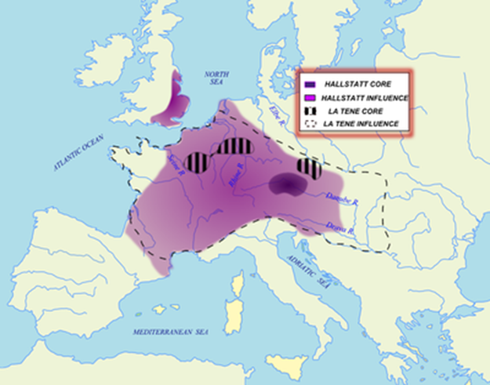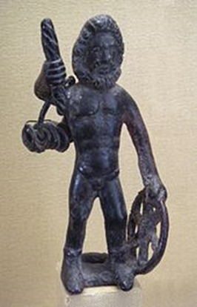
Taranis with Celtic wheel and thunderbolt

What did they look like?
The fourth-century Roman historian Ammianus Marcellinus wrote that the Gauls were tall, light-skinned, light-haired, and light-eyed:
“Almost all Gauls are tall and fair-skinned, with reddish hair. Their savage eyes make them fearful objects; they are eager to quarrel and excessively truculent. When, in the course of a dispute, any of them calls in his wife, a creature with gleaming eyes much stronger than her husband, they are more than a match for a whole group of foreigners; especially when the woman, with swollen neck and gnashing teeth, swings her great white arms and begins to deliver a rain of punches mixed with kicks, like missiles launched by the twisted strings of a catapult.”

The first century BCE Greek historian Diodorus Siculus described them as tall, generally heavily built, very light-skinned, and light-haired, with long hair and mustaches:
The Gauls are tall of body, with rippling muscles, and white of skin, and their hair is blond, and not only naturally so, but they make it their practice to increase the distinguishing color by which nature has given it. For they are always washing their hair in limewater, and they pull it back from their forehead to the top of the head and back to the nape of the neck... Some of them shave their beards, but others let it grow a little; and the nobles shave their cheeks, but they let the mustache grow until it covers the mouth. ^{[13]}

What was their culture like?
The countries of Gaul were civilized and wealthy. Most had contact with Roman merchants and some, particularly those that were governed by republics had enjoyed stable political alliances with Rome in the past. All over Gaul, archeology has uncovered numerous pre-Roman gold mines (at least 200 in the Pyrenees), suggesting that they were very rich, also evidenced by large finds of gold coins and artefacts. Modern archeology strongly suggests that the countries of Gaul were quite civilized and very wealthy. Most had contact with Roman merchants and some, had enjoyed stable political alliances with Rome; these were probably the ones where the Galatian ancestors lived, however.
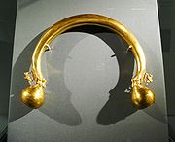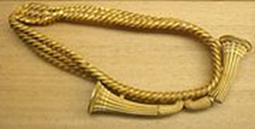
A 24 carat Celtic "torc", 480 BC A belt made of 6.2 lb of pure gold, 1200-1000 BC
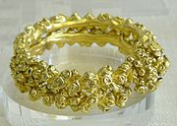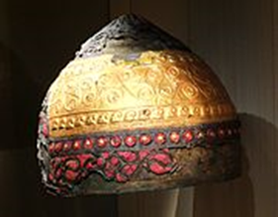
Celtic gold bracelet Celtic helmet 400 BC
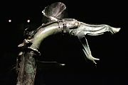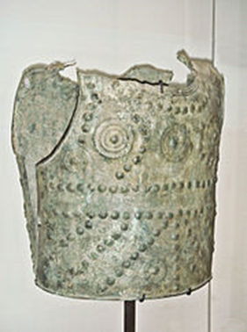
Celtic war trumpet Bronze cuirass,early 6th century BC
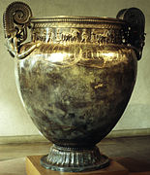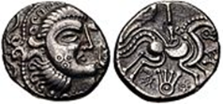
The Vix krater, 500 BC coin showing stylized head and horse circa 100-50BC

What was their language?
Gaulish or Gallic is the name given to the Celtic language that was spoken in Gaul before the Latin of the late Roman Empire became dominant in Roman Gaul. According to Julius Caesar in his Commentaries on the Gallic War, it was one of three languages in Gaul, the others being Aquitanian and Belgic.

The exact time of the final extinction of Gaulish is unknown, but it is estimated to have been around or shortly after the middle of the 1st millennium. Gaulish may have survived in some regions as the mid to late 6th century in France. Despite considerable Romanization of the local material culture, the Gaulish language is held to have survived and had coexisted with spoken Latin during the centuries of Roman rule of Gaul. Coexisting with Latin, Gaulish played a role in shaping the Vulgar Latin dialects that developed into French, with effects including loanwords and calques, sound changes shaped by Gaulish influence, and well as in conjugation and word order.

What was their original religion?
The historic Gauls practiced a form of animism, ascribing human characteristics to lakes, streams, mountains, and other natural features and granting them a quasi-divine status. Also, worship of animals was not uncommon; the animal most sacred to the Gauls was the boar, which can be found on many Gallic military standards, much like the Roman eagle.

Their system of gods and goddesses was loose, there being certain deities which virtually every Gallic person worshiped, as well as tribal and household gods. Many of the major gods were related to Greek gods; the primary god worshiped at the time of the arrival of Caesar was Teutates, the Gallic equivalent of Mercury. The "father god" in Gallic worship was "Dis Pater". However, there is no record of a theology, just a set of related and evolving traditions of worship.

Perhaps the most intriguing facet of Gallic religion is the practice of the Druids. There is no certainty concerning their origin, but it is clear that they vehemently guarded the secrets of their order and held sway over the people of Gaul. Indeed, they claimed the right to determine questions of war and peace, and thereby held an "international" status. In addition, the Druids monitored the religion of ordinary Gauls and were in charge of educating the aristocracy. They also practiced a form of excommunication from the assembly of worshippers, which in ancient Gaul meant a separation from secular society as well. Thus the Druids were an important part of Gallic society.

What was their military history?
The Romans respected and feared the Gallic tribes. Only fifty years before, in 109 BC, Italy had been invaded from the north and saved only after several bloody and costly battles by Gaius Marius. The Gauls were sometimes hired as mercenaries and were sometimes gladiators. A large number of Gauls served in the armies of Carthage during the Punic Wars, and one of the leading rebel leaders of the Mercenary War, Autaritus, was of Gallic origin.

Before being conquered by the Romans, the Gauls also campaigned into eastern Europe and Greece in an effort to get more land. They eventually were defeated in Greece, but this is how the ancestors of the Galatians ended up in the Balkans.

In 278 BC Gaulish settlers in the Balkans were invited by Nicomedes I of Bithynia to help him in a dynastic struggle against his brother. They numbered about 10,000 fighting men and about the same number of women and children, divided into three tribes. They were eventually defeated by the Seleucid king Antiochus I (275 BC), in a battle in which the Seleucid war elephants shocked the Galatians. Although the momentum of the invasion was broken, the Galatians were by no means exterminated, and continued to demand tribute from the Hellenistic states of Anatolia to avoid war. In a later battle with Greece at Thermopylae, they defeated the Greek army using the same approach used by the Persians earlier. The Greeks were forced to grant safe-passage to the Gauls who then made their way to Asia Minor and settled in Central Anatolia, where the Galatians of the New Testament were settled. The Gallic area of settlement in Asia Minor was called Galatia; there they created widespread havoc. But they were checked through the use of war elephants and skirmishers by the Greek Seleucid king Antiochus I in 275 BC.
4,000 Galatians were hired as mercenaries by the Ptolemaic Egyptian king Ptolemy II Philadelphus in 270 BC. Soon after arrival the Celts plotted “to seize Egypt”, and so Ptolemy marooned them on a deserted island in the Nile River.^{[6]}

Galatians continued to be a serious threat to the states of Asia Minor. In fact, they continued to be a threat even after their defeat in the Galatian War (189 BC). In that war, the Galatians sided with the Seleucid king, who lost to the Romans, so they then fell under Roman power. They were finally freed by the Mithridatic Wars, in which they supported Rome. In the settlement of 64 BC, Galatia became a client state of the Roman empire, the old constitution disappeared, and three chiefs were appointed, one for each tribe. But this arrangement soon gave way before the ambition of one of these tetrarchs, Deiotarus, a contemporary of Cicero and Julius Caesar, who made himself master of the other two tetrarchies and was finally recognized by the Romans as 'king' of Galatia. The Galatian language continued to be spoken in central Anatolia until the 6th century.^{[8]}
In the Second Punic War the famous Carthaginian general Hannibal used Gallic mercenaries in his invasion of Italy. They played a part in some of his most spectacular victories, including the battle of Cannae. The Gauls were so prosperous by the 2nd century that the powerful Greek colony of Massilia had to appeal to the Roman Republic for defense against them.

In 58 BC Julius Caesar launched the Gallic Wars and had conquered the whole of Gaul (France) by 51 BC. Caesar's motivation for the invasion seems to have been his need for gold to pay off his debts and for a successful military expedition to boost his political career. The people of Gaul could provide him with both. So much gold was looted from Gaul that after the war the price of gold fell by as much as 20%. While they were militarily just as brave as the Romans, the internal division between the Gallic tribes guaranteed an easy victory for Caesar. After the annexation of Gaul a mixed Gallo-Roman culture began to emerge.

